Zweig 2005 The implications of dependent plural readings

2. Dependant plurals
- Singulars in (1) and dependant plurals in (2) both have singular reference
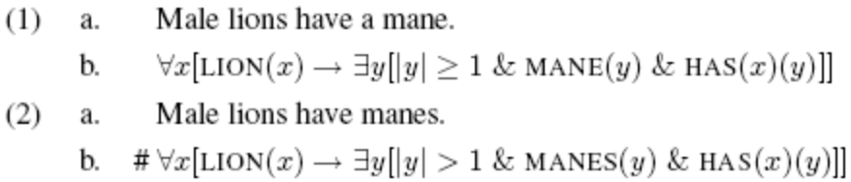
#Male lions should have a plurality of manes (each).
Instead it means the same as the singular in 1b,
if x is a male lion then y has a mane.
- However, dependant plurals must refer to more than one thing overall:
Dependant plural:
#They all live in Manhattan.
Singular:
They all live in Manhattan.

Manes is a dependant plural, a plural in the scope of a plural (lions).
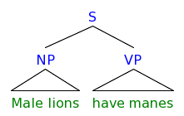
3. Are dependent plurals cumulative readings?

- de May 1981, Roberts 1990, Beck 2000, dependant plurals are like cumulative readings found in numerical indefinites:
- Minimal pair which seem to mean the same, with the two structures
Dependant plural
Cumulative
- However dependant plurals, unlike numerical indefinites, can appear in 2 environments
  - In the scope of quantifiers most and all
Cumulative:
Dependant Plural:
Cumulative:
Dependant Plural:

  - In the scope of quantified adverbials
Cumulative:
Dependant plural:

- Thus dependant plurals can’t be a subcase of cumulative readings.

4. The overall plurality requirement
- Chomsky 1975, Kamp and Reyle 1993, Spector 2003: dependant plural are semantically the same as the singular, but have obligatorily low scope.
- However, this doesn’t explain the overall plurality requirement.
- The plurality require coincides with pragmatic implications
- Lets look at different Entailment contexts
- Downward Entailing Contexts: no overall plurality requirement (13), no conversational implicature, (16)
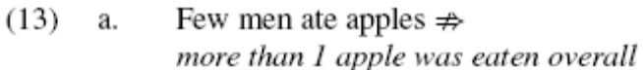
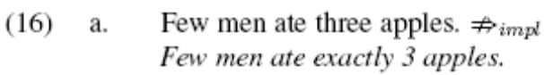
- Upward Entailing Contexts: conversational implicatures (17), and overall plurality requirement (18).
  - Both are even cancelable with pragmatic conditioning.
Conversational implicature: some ⇒ not all
Dependant plural: overall plurality
- Non-Monotone Contexts:
Dependant plural: overall plurality requirement
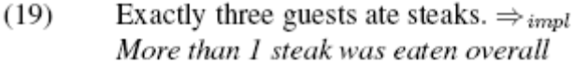
Conversational implicature: two ⇒ exactly two
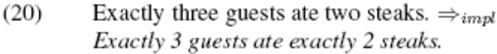
- Generalization

5. Number-neutral bare plurals outside dependent plurality
- Number neutral bare plurals can be found in other contexts where pragmatic strengthening is possible
- Sauerland et al. 2005: singular presupposes only a singular atomic entity, plural has no presupposition.
- Maximize Presupposition Principle (Heim 1991)
When choosing between two morphemes, the one whose stronger presuppositions can be satisfied must be chosen.
- Plural choice implies that the more informative singular wasn’t possible.
# John doesn’t own a small car.
# John owns a small car.
- However lexical blocking (using the Maximize Presupposition Principle) doesn’t always work, these seem to mean the same thing:
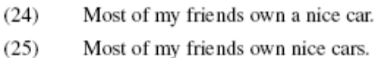
- Zweig’s proposal: number neutrality is supplemented by an implicature of a total plurality, rather than of non-local singularity
Since there is no quantification in this sentence which can result in a plural amount of cars, except the cars actually owned by John, the plurality implicature means that John owns several cars.

6. Formulating the plurality condition
- Schein 1993: some cumulative readings are composed of a conjunction
Therein is a definite description over events (baby-birthing) which refer back to the first event (women giving birth).

- Using Carlson 1980, bare plurals don’t QR
- Derivations for Upward Entailing Contexts
  - Dependant plurals
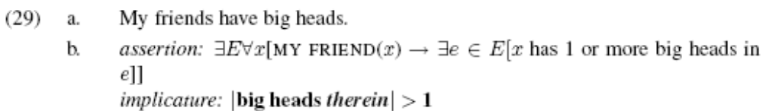
  - Bare plurals in other contexts
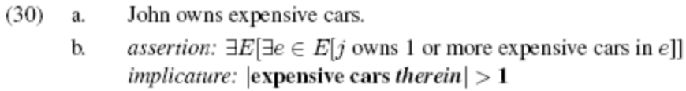
  - In the scope of a quantifying adverb (rough approximation)
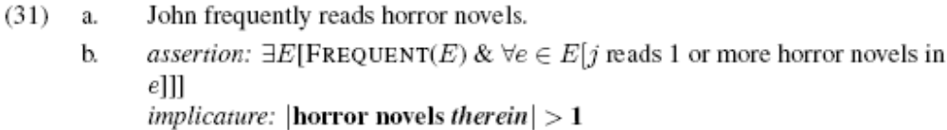
- Derivations for Downward Entailing Contexts
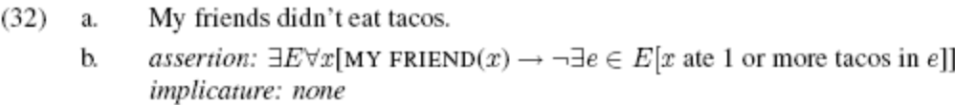

6.1. Intervention effects
- However, the overall plurality condition is subject to intervention effects, intermediate quantifiers create domains for the plurality implicature
- Two events, one AGENT(e) and GAVE A FLOWER(e)
- Current system derives a plurality implicature at the top level:
- Instead of at the intermediate level:
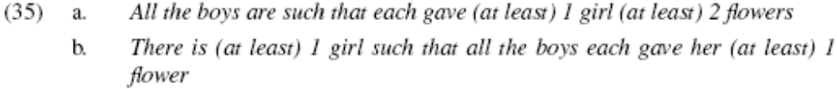
- Both scopes are shown in (36)
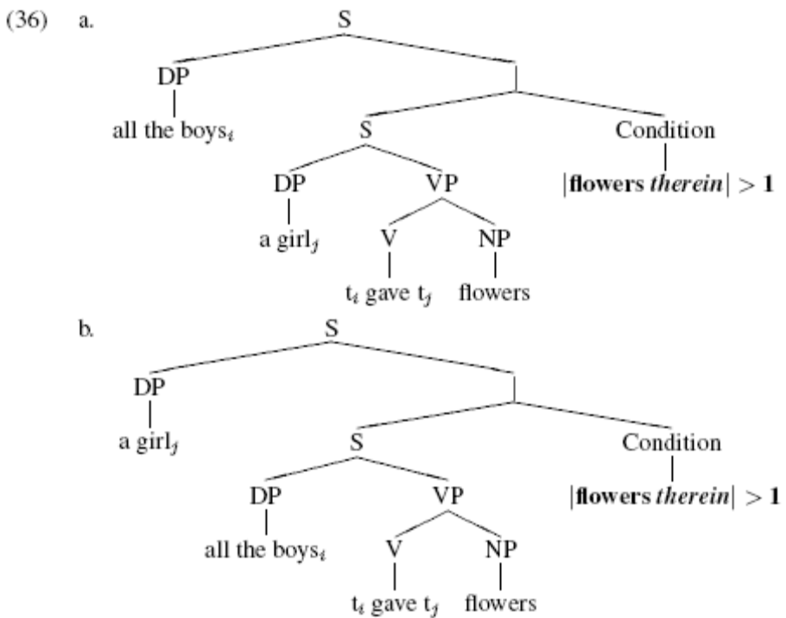
- We need the condition to refer to the lowermost event variable containing the plural (flowers), but implications don’t typically operate this way.
- (Chierchia 2002 suggests that scalar implicatures (and thus this plurality implicature) can infact be calculated locally, putting that aside and assuming that they can’t:)
- There is a first order event E₁ which contains subevents of agents, and a second order event E₂ which contains subevents of flower-giving.
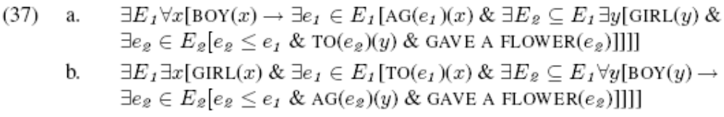
- Instead, since E1 contains E2, and a superset cant contain less than its subset, the agent event set E1 will also contain a plurality of flowers.
- This only holds in non-Downward entailing environments, and so the overall plurality requirement won’t arise.
- So we don’t need a definite therein, instead we need a universal therein’ a definite description of all the first order events (agent(e) in this case) which contain the plural element.
- This makes no change for the derivations in (29-31), and makes sure that a plurality in the embedded event in (33) is present in the matrix event.

7. Dependent plural readings and de re
- Partee 1985, singulars (39a) and dependant plurals (39c) can have both de re and de dicto readings, and bare plurals (39b) cannot
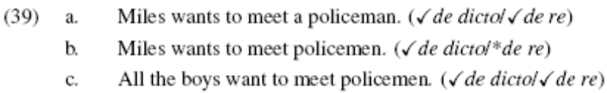
- In fact it is possible to get the de re reading for bare plurals:
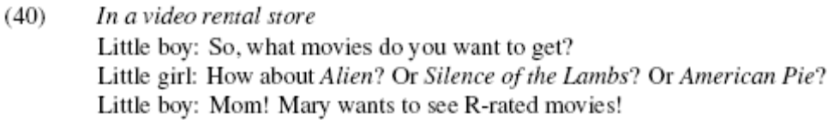
- The de re meaning is problematic for Carlson 1980, which assumes that bare plurals cannot QR, yet in order to get de re its assumed to have QR-ed
- However, this is getting scope over an intensional operator rather than quantification
- Maybe getting scope with intentional operators and getting scope with quantification/negation are not done by the same mechanism (Farkas 1997).
8. Conclusion
- Dependant plurals might help explain bare plurals.
- The interpretation of bare plurals can be split into two parts
  - Number neutral existential statement
  - A plurality implicature which results in plurality in upward entailing environments
- Closer to an account of the plural morpheme.
References
Zweig, Eytan (2006). ‘The implications of dependent plural readings’, in Davis, C., Deal, A. R. & Zabbal, Y. (eds.) NELS 36: Proceedings of the thirty-sixth annual meeting of the North East Linguistic Society pp. 735-746.

